1. Run dcomcnfg in start to open the Component Services Administrative tool
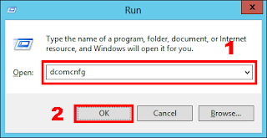

2. Click on Local DTC and open the property window
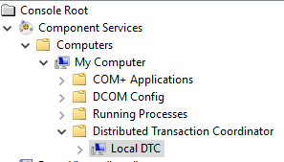

3. Click on security Tab and make below security settings to enable Network DTC Access

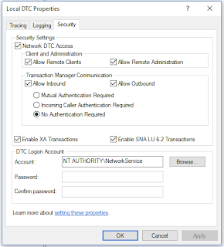

- Enabled Firewall Rules related to Distributed Transaction Coordinator (TCP-IN/TPC-Out) :
1. Open the Window Firewall
2. Click on the Advanced Security :
▪ Inbound Rules -> Distributed Transaction Coordinator (TCP-IN) → Enabled
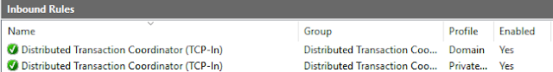

▪ Outbound Rules -> Distributed Transaction Coordinator (TCP-Out) → Enabled
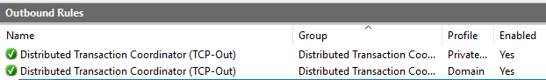

Thanks for Visiting!!

